

My school will go to the NGV. The letters N-G-V stands for National Gallery of Victoria. We can also call it the Gallery.

The Gallery is a very large building that has lots of old and new art from all over the world. I may see paintings, sculptures, photographs, fashion, drawings, films, and ancient objects. There are things that artists have made using different materials.

I can look, listen and learn at the Gallery.

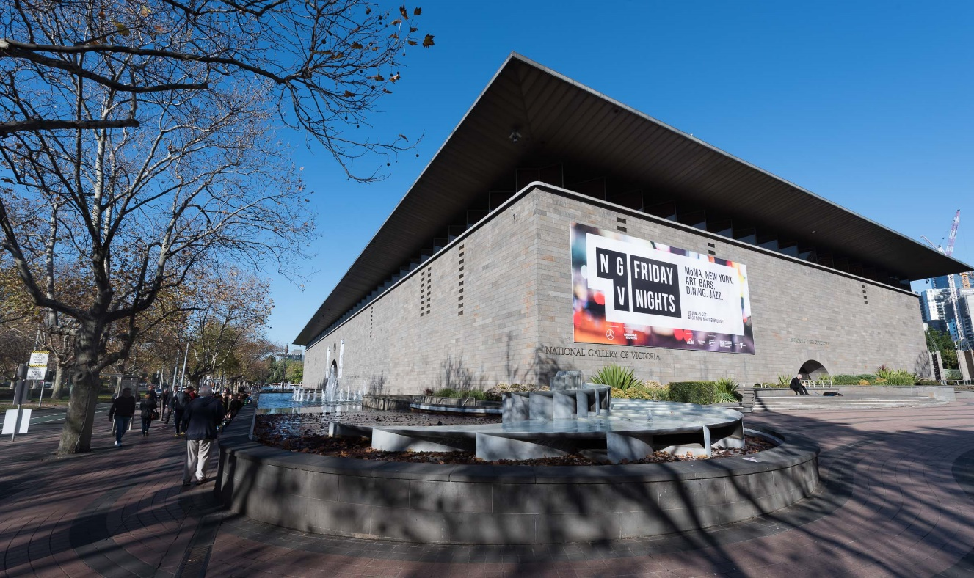

The Gallery has a main entrance with water out the front. Today I will use a different entrance because I am with my school.

I will go into the Gallery through the schools’ entrance. It is located around the side from the main entrance.

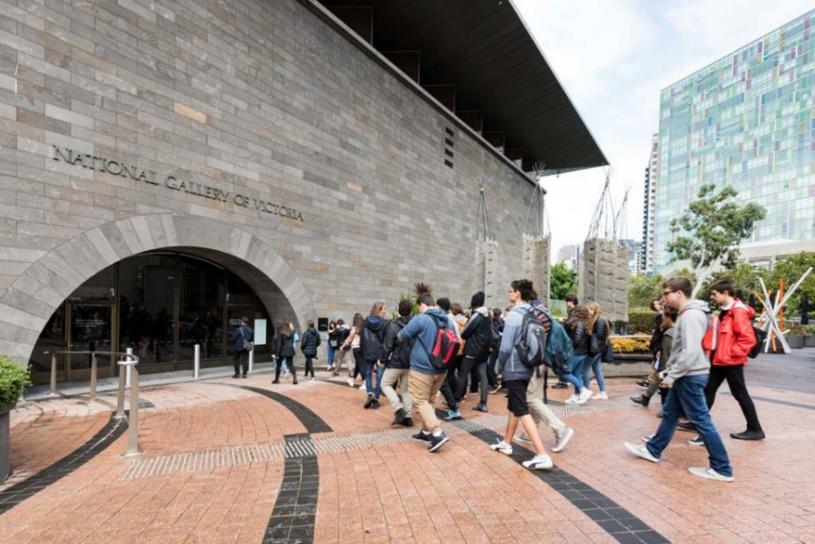 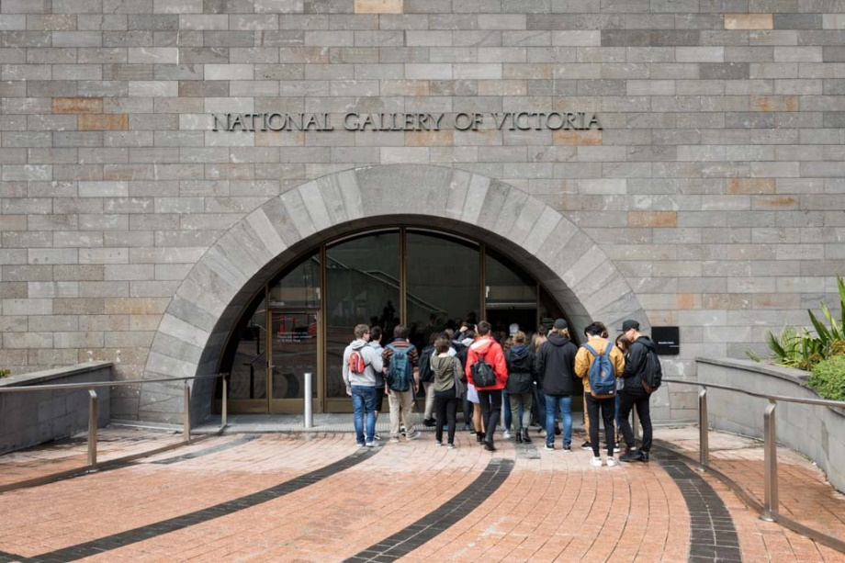

I will meet a member of the NGV Learning Staff. They work at the Gallery and are very nice.

They will look after me during my visit, make sure I stay safe and have fun.

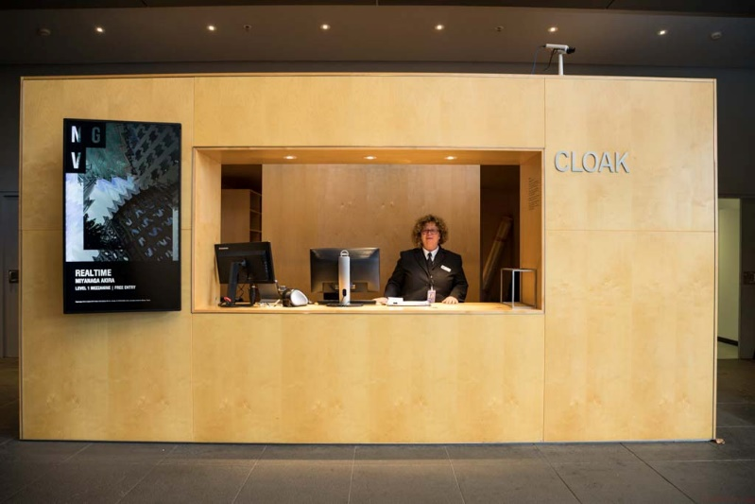 

I will put my bag inside a locker. It looks like a big cupboard. I may have to wait. This is okay.

The locker will be locked. My teacher will have the key.

Someone will look after my bag and I will get it back later. If I don’t have a bag, I will wait for my teacher.

Sometimes this area has lots of students from other schools and it can be crowded and noisy.

I will tell my teacher or my adult if I do not like this area. We can go to another room. This is okay

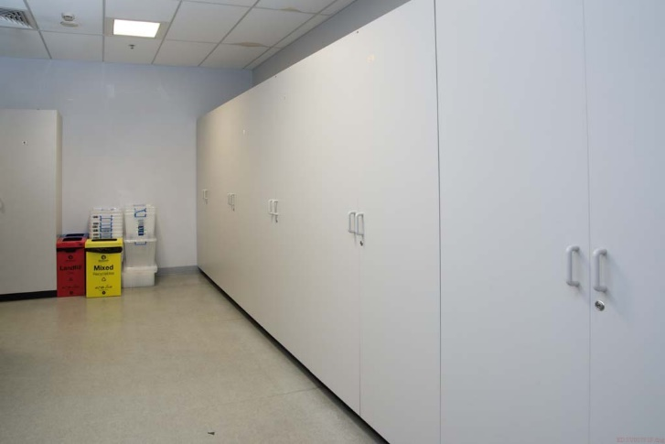 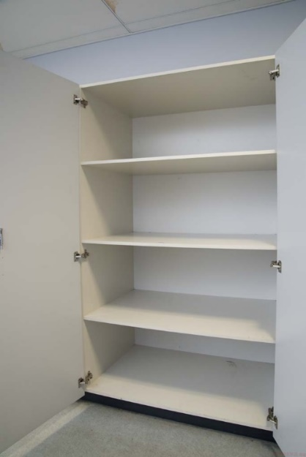 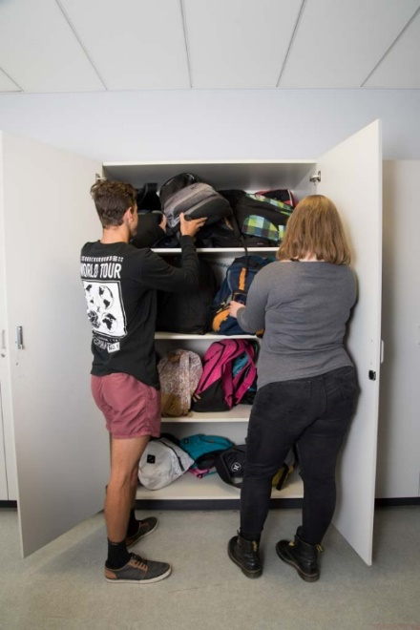

My teacher knows what we are going to do and when. When seeing a special exhibition, I may go upstairs with my group to a lecture theatre or Learning room.

The NGV Learning Staff will talk to us about what we are going to see and do.

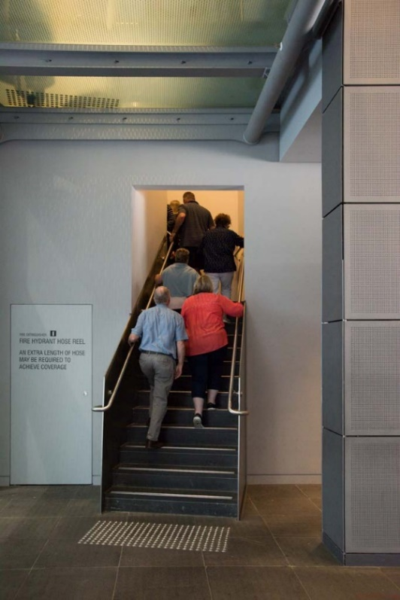 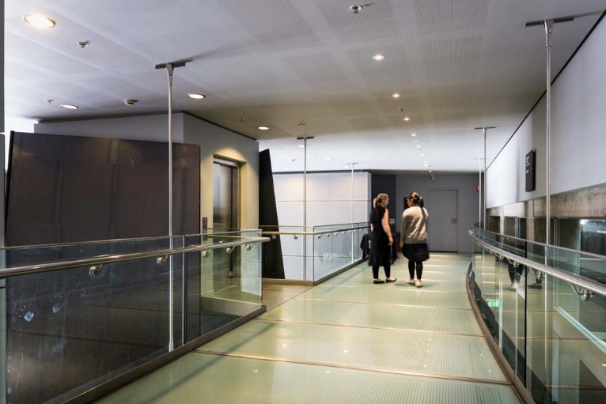

I may be taken to room or a lecture theatre with rows of seats.

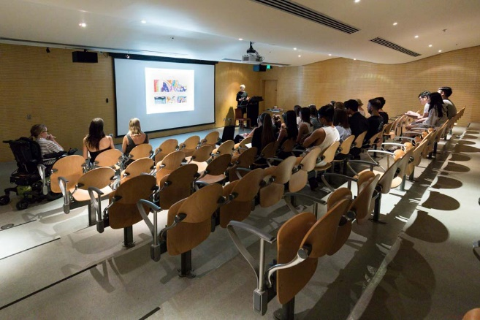 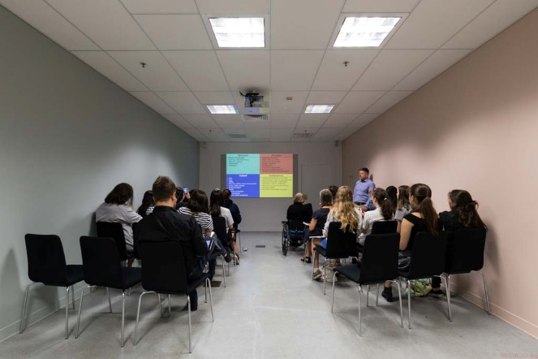

I will go with my group on a guided tour to see some of the artworks in the Gallery.

The NGV Learning Staff will lead our group on this tour around the Gallery and show us different artworks. We may see paintings, drawings, sculptures, photographs, fashion, films, and cultural objects. Each artwork has a story and I can learn about this at the Gallery.

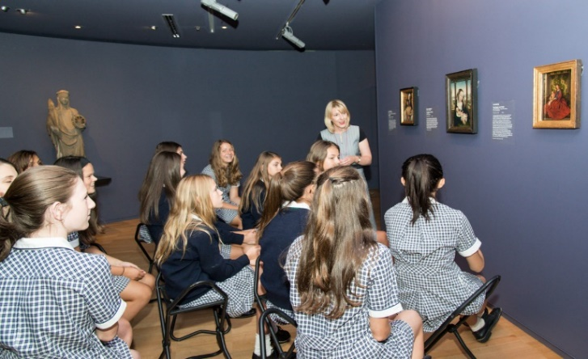 I:\EDUCATION\PHOTOS & VIDEOS\2015 photos\APPROVED TO USE\Misc photos\EDSV000872.tif

There are many different rooms. We will not visit all the rooms in the Gallery, as we will only have a short time.

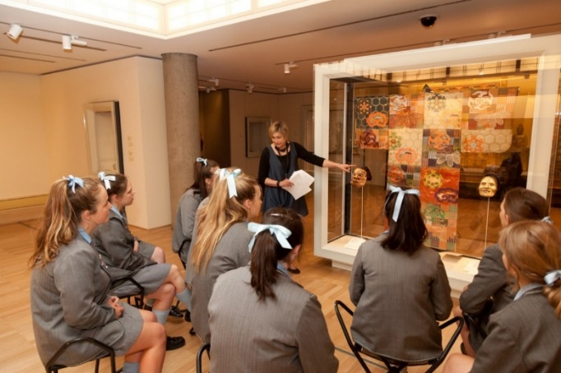

The Gallery has different levels and many rooms. There are escalators and lifts to take people to the different floors.

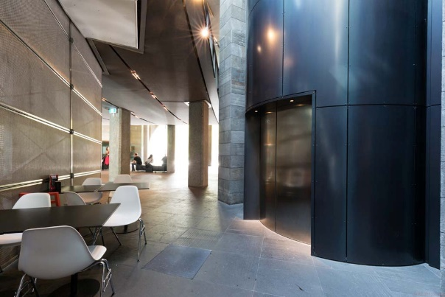 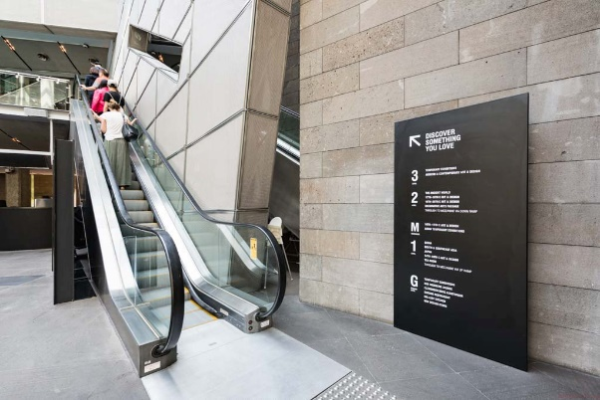

Some of the floors are made of glass. I may see people walking above me on a glass floor. This floor is made of very strong glass and it will not break. This floor is held up by strong metal and it will not fall on me.

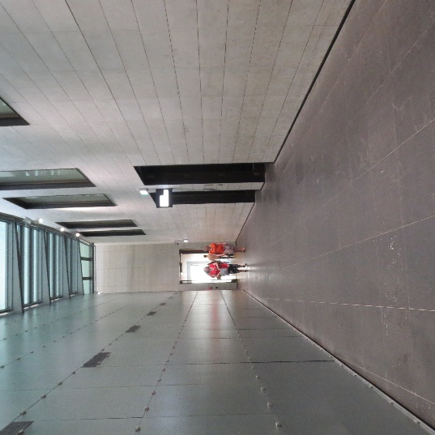 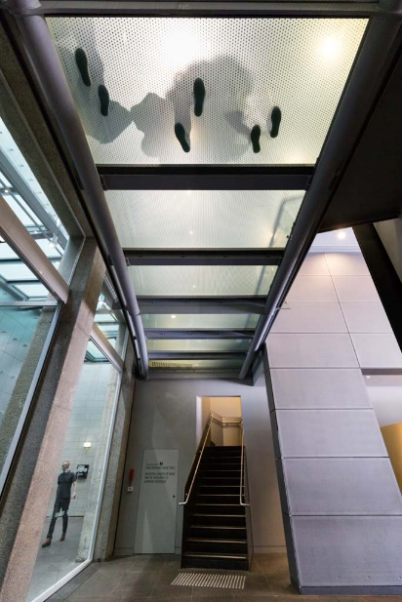

Inside the Gallery, there are big spaces with high walls. These spaces may have people and noises in it.

Some rooms may be dark or bright. Some parts of the Gallery are quiet. Some parts of the Gallery are loud.

I will tell my teacher or my adult if I do not like the room. This is okay.

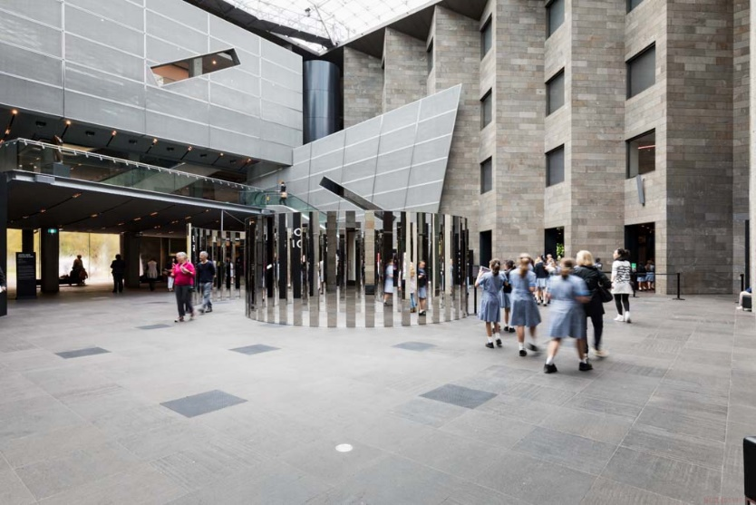 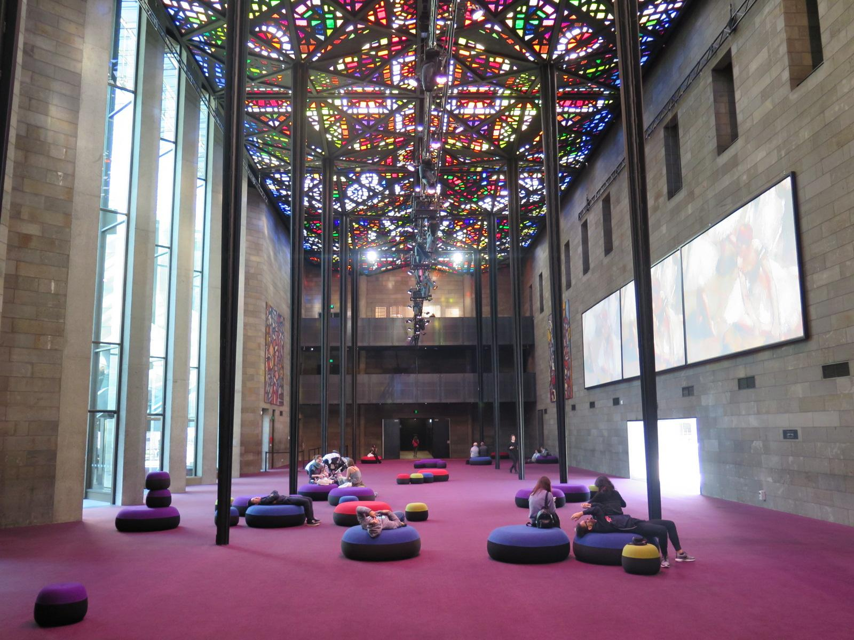

It is important that I follow the rules when visiting the gallery

At the Gallery, I will not touch the art, display cases or walls. This keeps the artwork clean and safe.

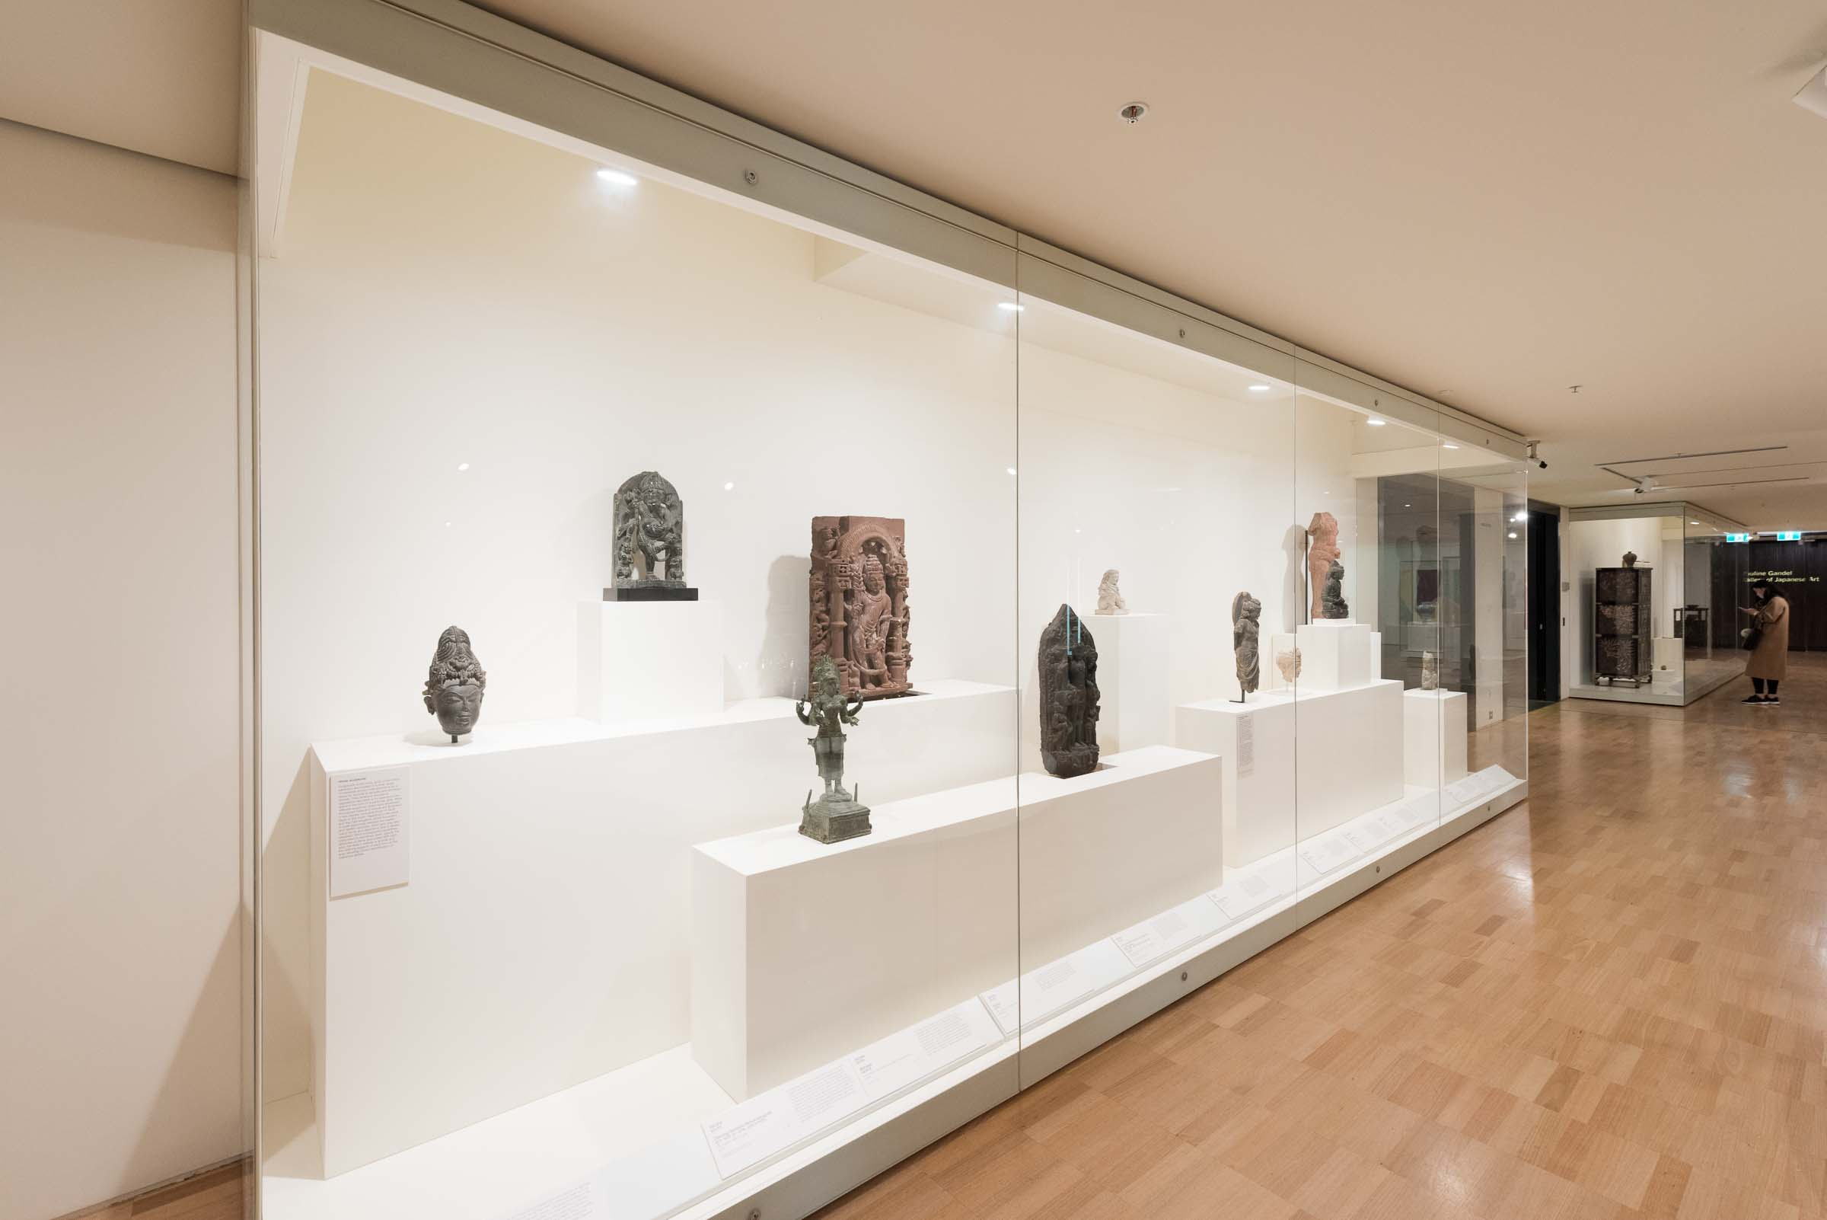

When I visit the NGV, I must remember to:

* Stay with my group or my adult
* Follow the adult who is leading my group
* Walk
* Speak with my inside quiet voice, even though it may be noisy
* Wait my turn
* Ask my teacher or my adult before I touch things

I may be able to visit the NGV store. The store sells books, postcards and even clothes! I will ask my teacher or my adult before I touch anything.

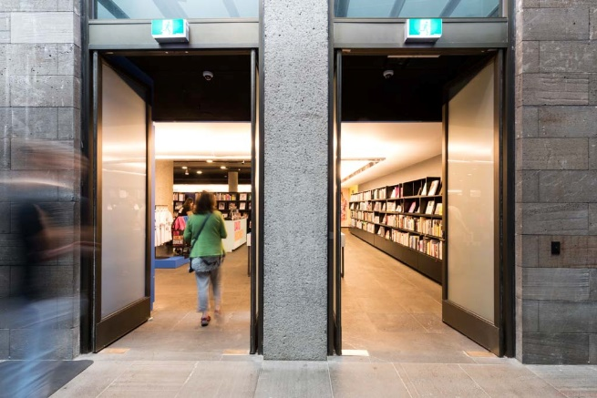 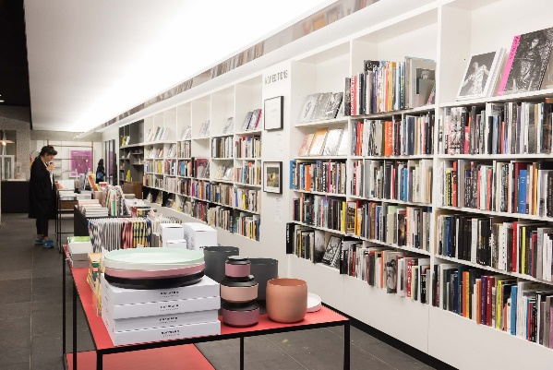

After the tour, I may do an art-making workshop to create my own artwork.

I will do the workshop in the Learn Art Studio, which is set up like an art room.

The NGV Learning Staff will show me the location of the workshop and they will take me there.

The NGV Learning Staff will show me what to do in the workshop. I will use a range of art materials to make something that I will be able to take home.

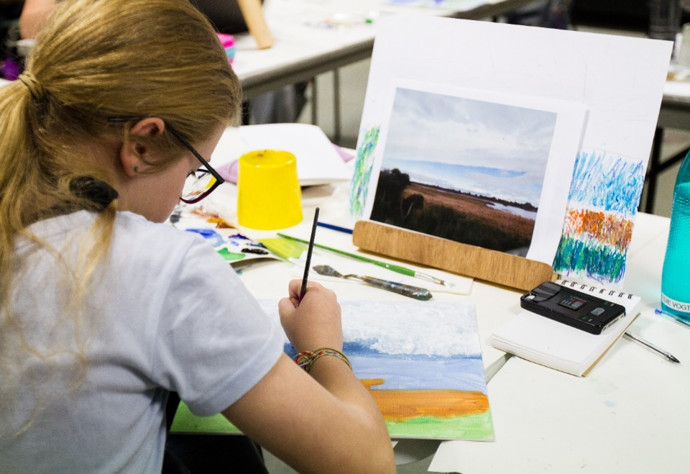

I will see security guards in the gallery spaces. They are there to help people and to keep the artworks safe.

The security guards wear black pants, black jackets, and white shirts with a black tie. The security guards also wear name tags.

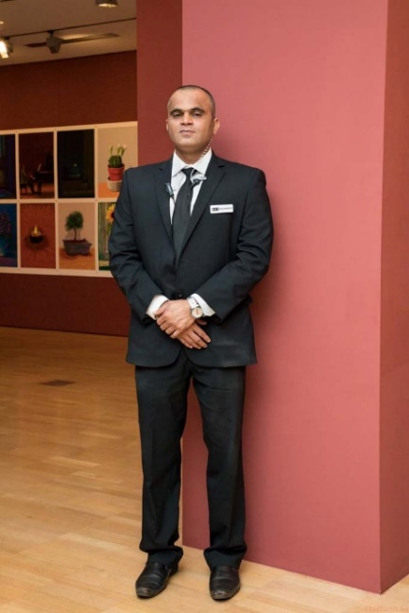 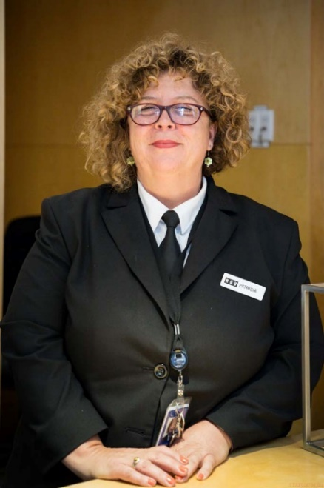

Gallery staff wear black and white t-shirts with the letters N-G-V printed on them. NGV stands for National Gallery of Victoria.

I can tell one of the Gallery staff or security guards if I need help. They are friendly and they will help me.

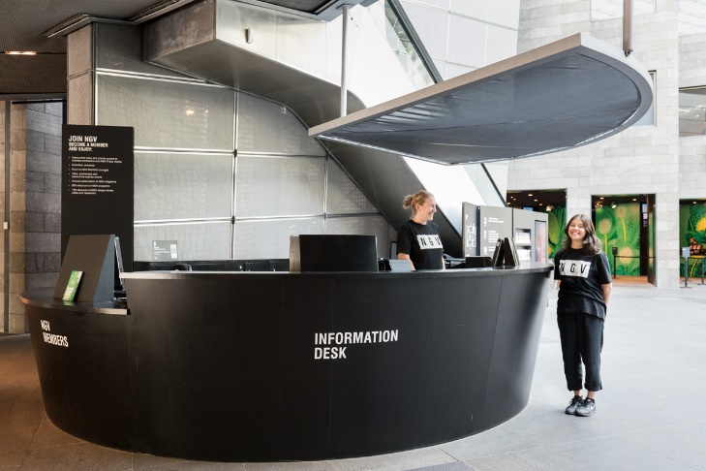

There are lots of toilets at the Gallery. I will ask my teacher or my adult when I need the toilet and how to find it. When I am finished using the toilet, I will wash my hands.

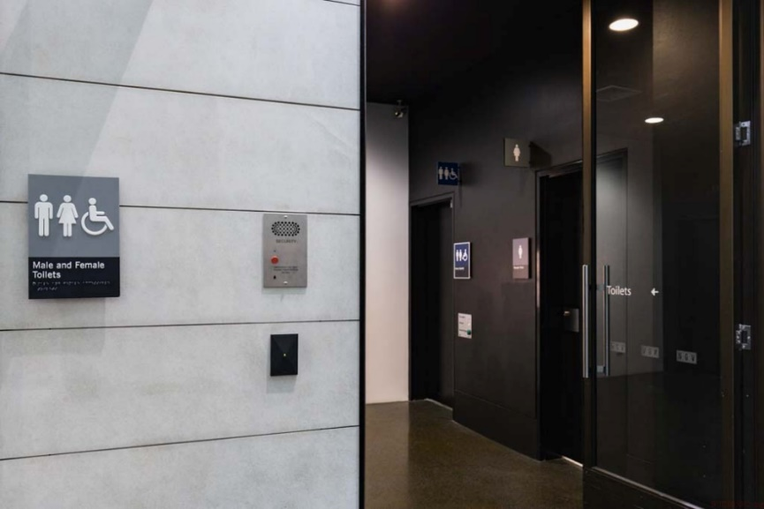 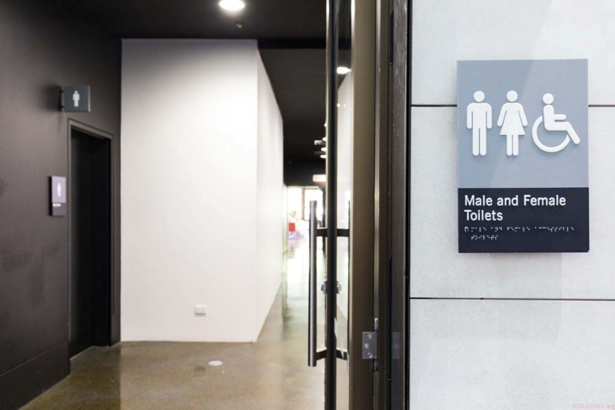

When it is lunch time, my teacher will show me where I can find my lunch.

I can sit in the Great Hall or in the garden to eat my food with my class. My teacher will show me where I will be eating.

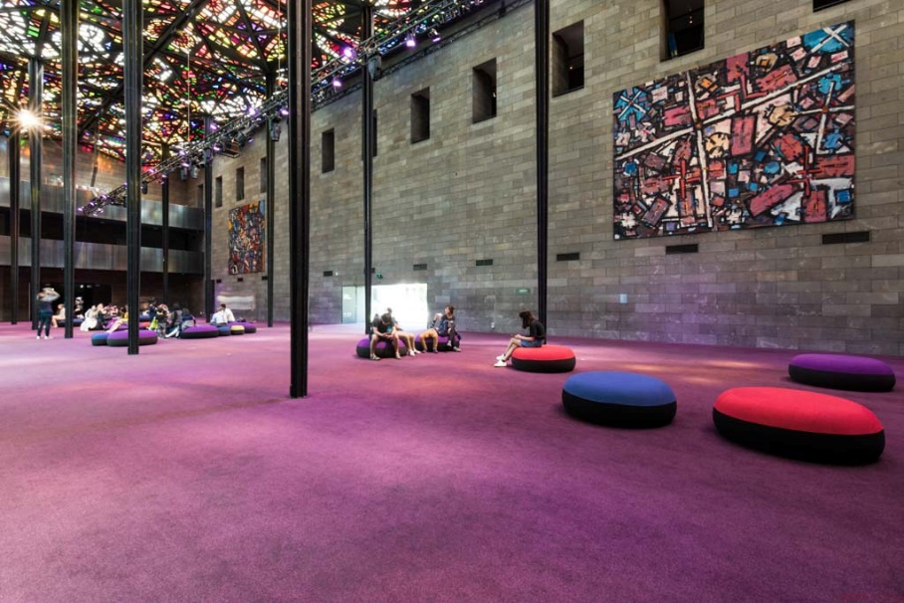 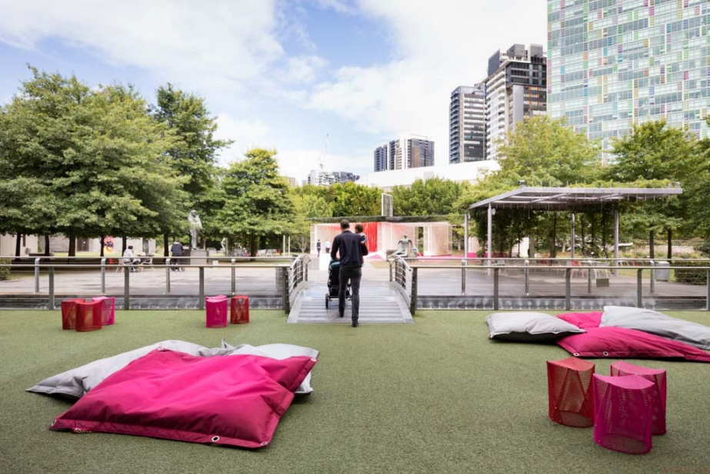

When it is time to leave, we will go back to the locker room. I will collect my bag from our locker. I may have to wait. This is okay.

Sometimes this area has lots of students from other schools and it can be crowded and noisy. I will tell my teacher or my adult if I do not like this area and we can go to another room. This is okay.

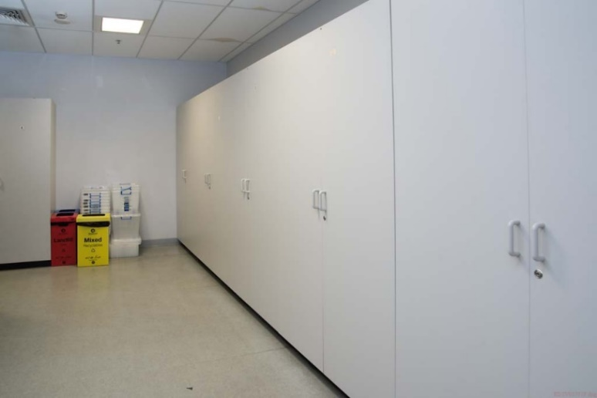 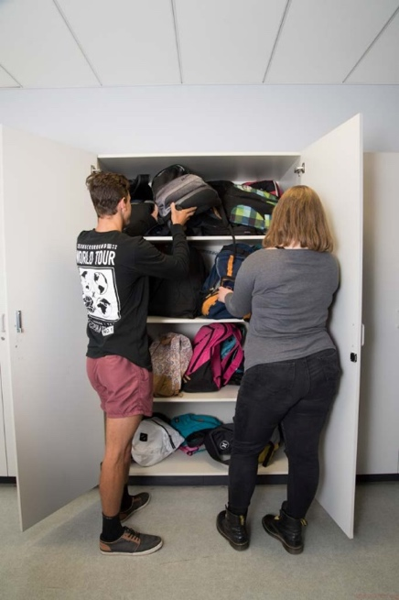 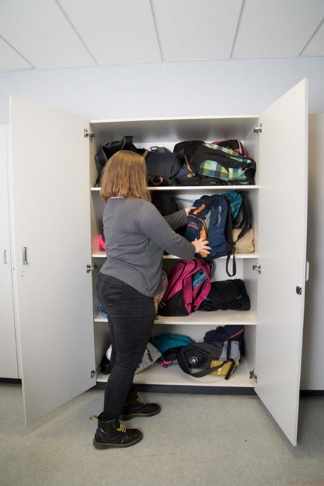

I will leave the Gallery through the same door that I used to enter.

Going to National Gallery of Victoria can be lots of fun!

